Christmas Wreath DIY
- How to:
- these videos are short, precise and basic (wire ring version) https://www.youtube.com/watch?v=s1kUKXIEouE
https://www.gartenhaus-gmbh.de/magazin/oh-du-froehlicheweihnachtliche-dekoration-im-garten/
- there are many other options, just check out Pinterest, Instagram & Co. (wreaths with foam, wreaths with willow/birch branches, grapevines, etc.)
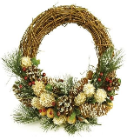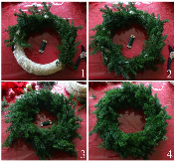
- your best friends: glue gun and wire

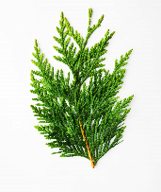
- What greens are best: KEEP ALL GREENS IN WATER UNTIL YOU MAKE THE WREATH!!!

Arborvitae, Thuja, Cedar, etc.: soft, easy to work with; don’t lose needles after drying out

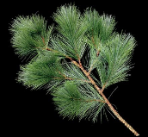
Pine: long soft needles, easy to work with;doesn’t lose needles too badly

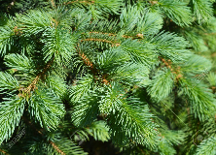
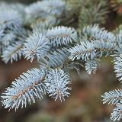
Blue and Green Spruce: prickly, less flexible branches; will loose needles very soon without sealant or constant spraying

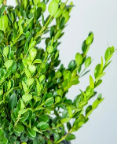
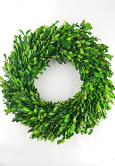
Boxwood: modern, evergreen, no needles; can be found in most gardens; dries out without losing leaves or color

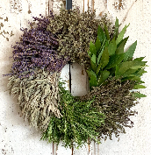
Herbs: modern and retro; can be added into above greens, too; lovely fragrance

